|  |  |  |  |
| --- | --- | --- | --- |
| Class Name  Class Specification | Constructor | Properties | Method |
| … |  |  |  |
| Deck | +Deck():  -creates deck | -intializeDeck(): void:  -initializes deck  -rank: String[]  -sets the rank as a text  -suits: String[]  -sets the suit as a text  -deckStack:ArrayList  -creates card stack as an array | getCard(index:int):  - gets the deck of cards  getStore():  -takes the created deck of cards and make it into an array  deckShuffle(): void: shuffles the deck of cards |
| Card | +Card(suit: String, rank: String):  - this will get the cards including suit and rank | -suit: String  -sets the suit as a text  -rank: String  … | + getDraggable() : boolean  -gets boolean  … |

State Transition diagram

Game Player’s Opens Application

Game Player Resumes Last Move

Game Player

Pauses Game

Start

Draws Card

Starts New Game

.…..

……

Pause

Resume

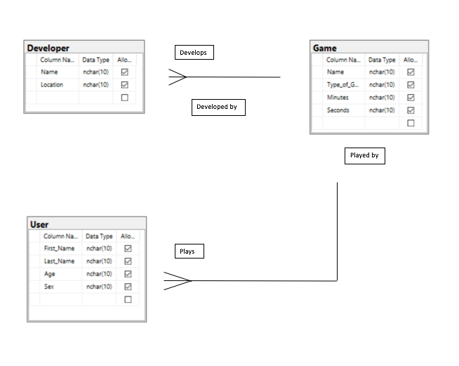

Entity Relationship Diagram